NAME: PRATIBA.S DATE:18.08.25 ROLL NO.:241901080

# EXERCISE 1

 **BASIC LINUX AND WINDOWS NETWORKING COMMANDS**

**AIM:**

 To explore and practice basic linux and windows network command.

**LINUX COMMANDS:**

1. ls – list directory

Synopsis: ls [option]… [File]…

Description: Display files and directories in the current working directory. By default, entries are sorted alphabetically.

2. touch – change file / create empty file

Synopsis: touch [option]… [File]…

Description: Shows detailed information for each file including permissions, owner, size, and time.

3. cat– concatenate and display file contents

Synopsis: cat [option]… [file]

Description: Prints the contents of one or more files to standard output. Useful for viewing or combining files.

4. ls-l – long listing format

Synopsis: ls -l

Description: Shows detailed information for each file including permissions, owner, size.

5. chmod – change file permissions

Synopsis: chmod [option]… mode file

Description: Changes the permission bits of files. You can use numeric or symbolic notation.

6. mkdir – make directories

Synopsis: mkdir [option]… Directory

Description: Creates a new directory. Use -p to create parent directories as needed.

7.ls -a – list all files including hidden

Synopsis: ls -a

Description: Lists all files, including hidden ones, inside the open directory.

8. nano – text editor

Synopsis: nano [file]

Description: Launches a user-friendly text editor in the terminal to edit files.

9. rm* – remove files

Synopsis: rm [option]… File…

Description: Deletes files or directories. Use -r for recursive removal, -f to force without prompt.

10. rmdir – remove empty directories

Synopsis: rmdir (directory)

Description: Deletes a directory only if it is empty.

11. ps -e – list all running processes

Synopsis:ps -e

Description: Shows currently running processes in the system.

12. grep – search for text patterns inside files or output

Synopsis: grep "word" file.txt

Description: Filters process list to show only those matching the given name or keyword.

13. echo– display text, variables or messages

Synopsis:echo [string]

Description: Prints the given text to the terminal. Often used in scripting.

14. top– real-time process viewer

Synopsis:top

Description: Displays a dynamic list of running processes along with CPU and memory usage.

15. free* – display memory message

Synopsis:free [option]

Description: Shows the amount of free and used memory in the system. Use -h for human-readable output.

16. vmstat – report system performance

Synopsis: vmstat [delay] [count]

Description: Displays memory, CPU, I/O, system performance statistics.

17. traceroute – tracks the path

Synopsis: traceroute [IP address/hostname]

Description: Identifies the path taken by packets to reach a network host.

18. ping – test network connectivity

Synopsis: ping [destination]

Description: Sends ICMP echo requests to a network host to check if it's reachable.

19. ifconfig – view network interfaces

Synopsis: ifconfig

Description: Displays or configures network interface parameters (now largely replaced by ip addr).

20. vi – text editor

Synopsis: vi [file]

Description: Opens the vi editor to create or modify files; offers powerful editing features.

21. cd – change directory

Synopsis: cd [directory]

Description: Changes the current working directory.

22. pwd – print working directory

Synopsis: pwd

Description: Shows current location.

**WINDOWS COMMANDS:**

1. dir - Equivalent of ls

Synopsis dir [path] [[options]]

Description: List all files and directories.

2. cd- Change directory

Synopsis:cd [path]

Description: Changes the current working directory.

3. cls- Clear screen

Synopsis: cls

Description: Removes all text.

4. echo - Prints

Synopsis: echo [message]

Description: Displays messages, useful in batch scripts.

5. dir -a (like ls -a)

Synopsis: dir -a [path]

Description: Lists files and directories.

6. mkdir - make directory

Synopsis: mkdir [drive:] [path] foldername

Description: Create a new directory in a specified path.

7. del - delete file (remdir)

Synopsis: del file.txt

Description: Delete files or directories from the file system.

8. tasklist - display all currently running process

Synopsis: tasklist [options]

Description: Lists process name, PID (Process ID), session name/ID, and memory usage.

9. find - search for a specific string of text within files

Synopsis: find "string" [filename]

Description: Looks for the given "string" inside the specified file.

10. systeminfo - detailed system configuration information

Synopsis: systeminfo

Description: Often used for system audits and troubleshooting.

11. typeperf - display or log performance counter data

Synopsis: typeperf [counter...] [options]

Description: Can display output in the console or save it to a log file (CSV, TSV, binary).

12. tracert - Trace the path packets take to reach

Synopsis: tracert [options] <hostname or IP>

Description: Displays each router packets travel through until reaching the destination.

13. ping - network connectivity

Synopsis: ping [option] <hostname or IP>

Description: Displays packet loss, response time, and TTL (Time to Live).

14. ipconfig - displays and manages IP address

Synopsis: ipconfig [options]

Description: Shows current network adapter configuration.

**OUTPUT:**







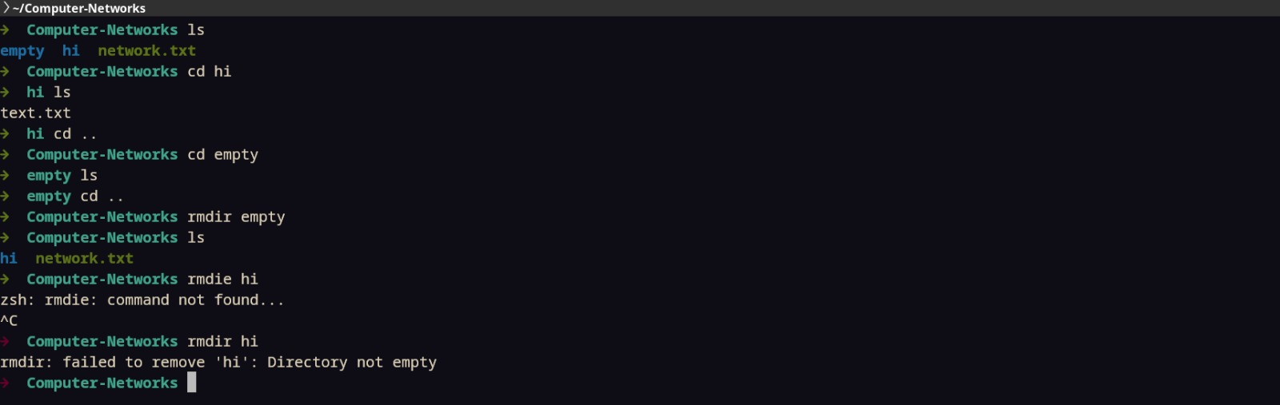

**RESULT:**

All Linux and Windows commands are practiced.